**CHAPTER 6**

**Decision Trees**



With Early Release ebooks, you get books in their earliest form— the author’s raw and unedited content as he or she writes—so you can take advantage of these technologies long before the official release of these titles. The following will be Chapter 6 in the final release of the book.



Like SVMs, *Decision Trees* are versatile Machine Learning algorithms that can per‐ form both classification and regression tasks, and even multioutput tasks. They are very powerful algorithms, capable of fitting complex datasets. For example, in Chap‐ ter 2 you trained a DecisionTreeRegressor model on the California housing dataset, fitting it perfectly (actually overfitting it).

Decision Trees are also the fundamental components of Random Forests (see Chap‐ ter 7), which are among the most powerful Machine Learning algorithms available today.

In this chapter we will start by discussing how to train, visualize, and make predic‐ tions with Decision Trees. Then we will go through the CART training algorithm used by Scikit-Learn, and we will discuss how to regularize trees and use them for regression tasks. Finally, we will discuss some of the limitations of Decision Trees.

**Training and Visualizing a Decision Tree**

To understand Decision Trees, let’s just build one and take a look at how it makes pre‐ dictions. The following code trains a DecisionTreeClassifier on the iris dataset (see Chapter 4):

**from sklearn.datasets import** load_iris

**from sklearn.tree import** DecisionTreeClassifier



**177**

iris = load_iris()

X = iris.data[:, 2:] *# petal length and width* y = iris.target

tree_clf = DecisionTreeClassifier(max_depth=2) tree_clf.fit(X, y)

You can visualize the trained Decision Tree by first using the export_graphviz() method to output a graph definition file called *iris_tree.dot*:

**from sklearn.tree import** export_graphviz

export_graphviz( tree_clf,

out_file=image_path("iris_tree.dot"), feature_names=iris.feature_names[2:], class_names=iris.target_names, rounded=True,

filled=True

)

Then you can convert this *.dot* file to a variety of formats such as PDF or PNG using the dot command-line tool from the *graphviz* package.1 This command line converts the *.dot* file to a *.png* image file:

$ dot -Tpng iris_tree.dot -o iris_tree.png

Your first decision tree looks like Figure 6-1.



1 Graphviz is an open source graph visualization software package, available at [*http://www.graphviz.org/*](http://www.graphviz.org/).



**178** **|** **Chapter 6: Decision Trees**

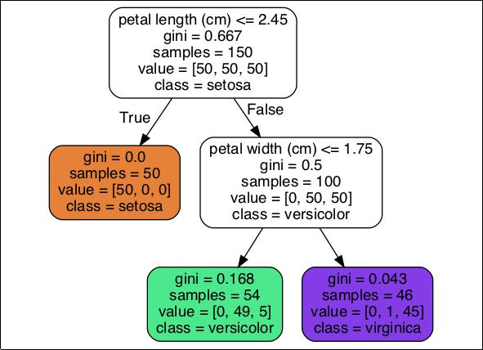

*Figure 6-1. Iris Decision Tree*

**Making Predictions**

Let’s see how the tree represented in Figure 6-1 makes predictions. Suppose you find an iris flower and you want to classify it. You start at the *root node* (depth 0, at the top): this node asks whether the flower’s petal length is smaller than 2.45 cm. If it is, then you move down to the root’s left child node (depth 1, left). In this case, it is a *leaf* *node* (i.e., it does not have any children nodes), so it does not ask any questions: youcan simply look at the predicted class for that node and the Decision Tree predicts that your flower is an Iris-Setosa (class=setosa).

Now suppose you find another flower, but this time the petal length is greater than 2.45 cm. You must move down to the root’s right child node (depth 1, right), which is not a leaf node, so it asks another question: is the petal width smaller than 1.75 cm? If it is, then your flower is most likely an Iris-Versicolor (depth 2, left). If not, it is likely an Iris-Virginica (depth 2, right). It’s really that simple.

One of the many qualities of Decision Trees is that they require very little data preparation. In particular, they don’t require feature scaling or centering at all.



**Making Predictions** **|** **179**

A node’s samples attribute counts how many training instances it applies to. For example, 100 training instances have a petal length greater than 2.45 cm (depth 1, right), among which 54 have a petal width smaller than 1.75 cm (depth 2, left). A node’s value attribute tells you how many training instances of each class this node applies to: for example, the bottom-right node applies to 0 Iris-Setosa, 1 Iris-Versicolor, and 45 Iris-Virginica. Finally, a node’s gini attribute measures its *impur‐* *ity*: a node is “pure” (gini=0) if all training instances it applies to belong to the sameclass. For example, since the depth-1 left node applies only to Iris-Setosa training instances, it is pure and its gini score is 0. Equation 6-1 shows how the training algo‐ rithm computes the gini score *Gi* of the ith node. For example, the depth-2 left node has a gini score equal to 1 – (0/54)2 – (49/54)2 – (5/54)2 ≈ 0.168. Another *impurity* *measure* is discussed shortly.

*Equation 6-1. Gini impurity*

*n*

*Gi* = 1 − *k*∑ *pi*, *k*2= 1

• *pi*,*k* is the ratio of class *k* instances among the training instances in the *i*th node.

Scikit-Learn uses the CART algorithm, which produces only *binary* *trees*: nonleaf nodes always have two children (i.e., questions onlyhave yes/no answers). However, other algorithms such as ID3 can produce Decision Trees with nodes that have more than two chil‐ dren.



Figure 6-2 shows this Decision Tree’s decision boundaries. The thick vertical line rep‐ resents the decision boundary of the root node (depth 0): petal length = 2.45 cm. Since the left area is pure (only Iris-Setosa), it cannot be split any further. However, the right area is impure, so the depth-1 right node splits it at petal width = 1.75 cm (represented by the dashed line). Since max_depth was set to 2, the Decision Tree stops right there. However, if you set max_depth to 3, then the two depth-2 nodes would each add another decision boundary (represented by the dotted lines).



**180** **|** **Chapter 6: Decision Trees**

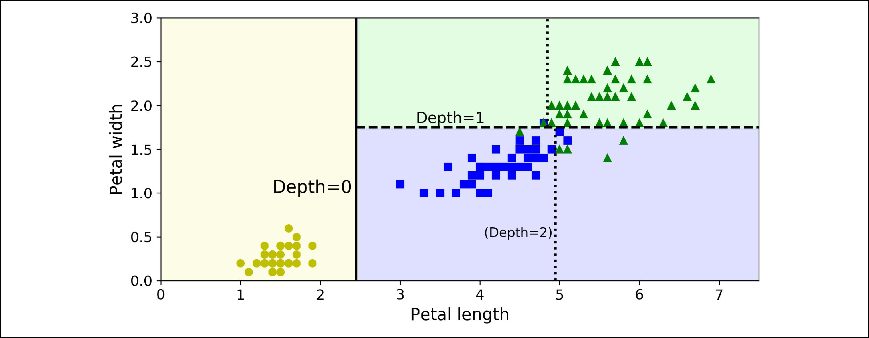

*Figure 6-2. Decision Tree decision boundaries*



**Model Interpretation: White Box Versus Black Box**

As you can see Decision Trees are fairly intuitive and their decisions are easy to inter‐ pret. Such models are often called *white box models*. In contrast, as we will see, Ran‐ dom Forests or neural networks are generally considered *black box models*. They make great predictions, and you can easily check the calculations that they performed to make these predictions; nevertheless, it is usually hard to explain in simple terms why the predictions were made. For example, if a neural network says that a particu‐ lar person appears on a picture, it is hard to know what actually contributed to this prediction: did the model recognize that person’s eyes? Her mouth? Her nose? Her shoes? Or even the couch that she was sitting on? Conversely, Decision Trees provide nice and simple classification rules that can even be applied manually if need be (e.g., for flower classification).

**Estimating Class Probabilities**

A Decision Tree can also estimate the probability that an instance belongs to a partic‐ ular class *k*: first it traverses the tree to find the leaf node for this instance, and then it returns the ratio of training instances of class *k* in this node. For example, suppose you have found a flower whose petals are 5 cm long and 1.5 cm wide. The corre‐ sponding leaf node is the depth-2 left node, so the Decision Tree should output the following probabilities: 0% for Iris-Setosa (0/54), 90.7% for Iris-Versicolor (49/54), and 9.3% for Iris-Virginica (5/54). And of course if you ask it to predict the class, it should output Iris-Versicolor (class 1) since it has the highest probability. Let’s check this:

|  |  |  |
| --- | --- | --- |
| **>>>** tree_clf.predict_proba([[5, | | 1.5]]) |
| array([[0. | , 0.90740741, | 0.09259259]]) |



**Estimating Class Probabilities** **|** **181**

**>>>** tree_clf.predict([[5,1.5]])array([1])

Perfect! Notice that the estimated probabilities would be identical anywhere else in the bottom-right rectangle of Figure 6-2—for example, if the petals were 6 cm long and 1.5 cm wide (even though it seems obvious that it would most likely be an Iris-Virginica in this case).

**The CART Training Algorithm**

Scikit-Learn uses the *Classification And Regression Tree* (CART) algorithm to train Decision Trees (also called “growing” trees). The idea is really quite simple: the algo‐ rithm first splits the training set in two subsets using a single feature *k* and a thres‐ hold *tk* (e.g., “petal length ≤ 2.45 cm”). How does it choose *k* and *tk*? It searches for the pair (*k*, *tk*) that produces the purest subsets (weighted by their size). The cost function that the algorithm tries to minimize is given by Equation 6-2.

*Equation 6-2. CART cost function for classification*

*J**k*, *tk*

where

= *m*left *G*left + *m*right *G*right *m m*

*G*left/rightmeasures the impurity of the left/right subset, *m*left/rightis the number of instances in the left/right subset.



Once it has successfully split the training set in two, it splits the subsets using the same logic, then the sub-subsets and so on, recursively. It stops recursing once it rea‐ ches the maximum depth (defined by the max_depth hyperparameter), or if it cannot find a split that will reduce impurity. A few other hyperparameters (described in a moment) control additional stopping conditions (min_samples_split, min_sam

ples_leaf, min_weight_fraction_leaf, and max_leaf_nodes).



**182** **|** **Chapter 6: Decision Trees**

As you can see, the CART algorithm is a *greedy algorithm*: it greed‐ ily searches for an optimum split at the top level, then repeats the process at each level. It does not check whether or not the split will lead to the lowest possible impurity several levels down. A greedy algorithm often produces a reasonably good solution, but it is not guaranteed to be the optimal solution.

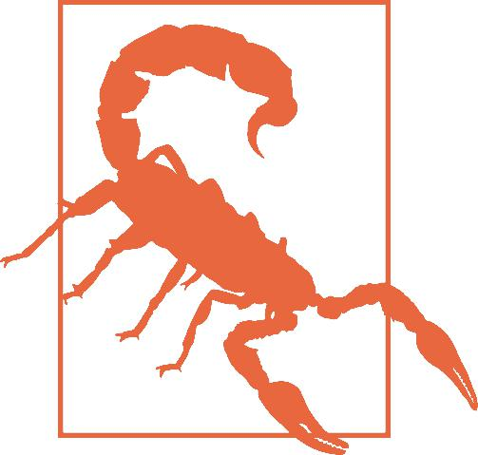

Unfortunately, finding the optimal tree is known to be an *NP-Complete* problem:2itrequires *O*(exp(*m*)) time, making the prob‐lem intractable even for fairly small training sets. This is why we must settle for a “reasonably good” solution.

**Computational Complexity**

Making predictions requires traversing the Decision Tree from the root to a leaf. Decision Trees are generally approximately balanced, so traversing the Decision Tree requires going through roughly *O*(*log*2(*m*)) nodes.3 Since each node only requires checking the value of one feature, the overall prediction complexity is just *O*(*log*2(*m*)), independent of the number of features. So predictions are very fast, even when deal‐ ing with large training sets.

However, the training algorithm compares all features (or less if max_features is set) on all samples at each node. This results in a training complexity of *O*(*n* × *m log*(*m*)). For small training sets (less than a few thousand instances), Scikit-Learn can speed up training by presorting the data (set presort=True), but this slows down training con‐ siderably for larger training sets.

**Gini Impurity or Entropy?**

By default, the Gini impurity measure is used, but you can select the *entropy* impurity measure instead by setting the criterion hyperparameter to "entropy". The concept of entropy originated in thermodynamics as a measure of molecular disorder: entropy approaches zero when molecules are still and well ordered. It later spread to a wide variety of domains, including Shannon’s *information theory*, where it measures the average information content of a message:4 entropy is zero when all messages are identical. In Machine Learning, it is frequently used as an impurity measure: a set’s



1. P is the set of problems that can be solved in polynomial time. NP is the set of problems whose solutions can be verified in polynomial time. An NP-Hard problem is a problem to which any NP problem can be reduced in polynomial time. An NP-Complete problem is both NP and NP-Hard. A major open mathematical ques‐ tion is whether or not P = NP. If P ≠ NP (which seems likely), then no polynomial algorithm will ever be found for any NP-Complete problem (except perhaps on a quantum computer).
2. *log*2is the binary logarithm. It is equal to *log*2(*m*) = *log*(*m*) / *log*(2).
3. A reduction of entropy is often called an *information gain*.



**Computational Complexity** **|** **183**

entropy is zero when it contains instances of only one class. Equation 6-3 shows the definition of the entropy of the ith node. For example, the depth-2 left node in Figure 6-1 has an entropy equal to − 4954 log2 4954 − 545 log2 545 ≈ 0.445.

*Equation 6-3. Entropy*

*n*

*Hi* = − *k*∑ *pi*, *k* log2 *pi*, *k*



= 1 *pi*, *k* ≠ 0

So should you use Gini impurity or entropy? The truth is, most of the time it does not make a big difference: they lead to similar trees. Gini impurity is slightly faster to compute, so it is a good default. However, when they differ, Gini impurity tends to isolate the most frequent class in its own branch of the tree, while entropy tends to produce slightly more balanced trees.5

**Regularization Hyperparameters**

Decision Trees make very few assumptions about the training data (as opposed to lin‐ ear models, which obviously assume that the data is linear, for example). If left unconstrained, the tree structure will adapt itself to the training data, fitting it very closely, and most likely overfitting it. Such a model is often called a *nonparametric* *model*, not because it does not have any parameters (it often has a lot) but because thenumber of parameters is not determined prior to training, so the model structure is free to stick closely to the data. In contrast, a *parametric model* such as a linear model has a predetermined number of parameters, so its degree of freedom is limited, reducing the risk of overfitting (but increasing the risk of underfitting).

To avoid overfitting the training data, you need to restrict the Decision Tree’s freedom during training. As you know by now, this is called regularization. The regularization hyperparameters depend on the algorithm used, but generally you can at least restrict the maximum depth of the Decision Tree. In Scikit-Learn, this is controlled by the max_depth hyperparameter (the default value is None, which means unlimited). Reducing max_depth will regularize the model and thus reduce the risk of overfitting.

The DecisionTreeClassifier class has a few other parameters that similarly restrict the shape of the Decision Tree: min_samples_split (the minimum number of sam‐ ples a node must have before it can be split), min_samples_leaf (the minimum num‐ ber of samples a leaf node must have), min_weight_fraction_leaf (same as min_samples_leaf but expressed as a fraction of the total number of weighted



5 See Sebastian Raschka’s [interesting analysis for more details](https://homl.info/19).



**184** **|** **Chapter 6: Decision Trees**

instances), max_leaf_nodes (maximum number of leaf nodes), and max_features (maximum number of features that are evaluated for splitting at each node). Increas‐ ing min_* hyperparameters or reducing max_* hyperparameters will regularize the model.

Other algorithms work by first training the Decision Tree without restrictions, then *pruning* (deleting) unnecessary nodes. A node whose children are all leaf nodes is considered unnecessary if the purity improvement it provides is not *statistically significant*. Stan‐ dard statistical tests, such as the *χ*2 *test*, are used to estimate the probability that the improvement is purely the result of chance (which is called the *null hypothesis*). If this probability, called the *p-value*, is higher than a given threshold (typically 5%, controlled bya hyperparameter), then the node is considered unnecessary and its children are deleted. The pruning continues until all unnecessary nodes have been pruned.



Figure 6-3 shows two Decision Trees trained on the moons dataset (introduced in Chapter 5). On the left, the Decision Tree is trained with the default hyperparameters (i.e., no restrictions), and on the right the Decision Tree is trained with min_sam ples_leaf=4. It is quite obvious that the model on the left is overfitting, and the model on the right will probably generalize better.

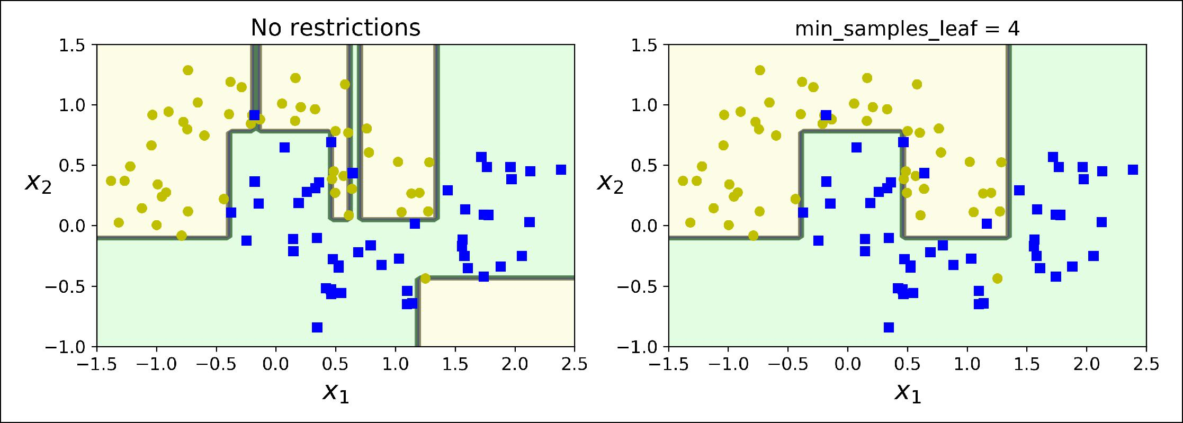

*Figure 6-3. Regularization using min_samples_leaf*

**Regression**

Decision Trees are also capable of performing regression tasks. Let’s build a regres‐ sion tree using Scikit-Learn’s DecisionTreeRegressor class, training it on a noisy quadratic dataset with max_depth=2:

**from sklearn.tree import** DecisionTreeRegressor



**Regression** **|** **185**

tree_reg = DecisionTreeRegressor(max_depth=2) tree_reg.fit(X, y)

The resulting tree is represented on Figure 6-4.

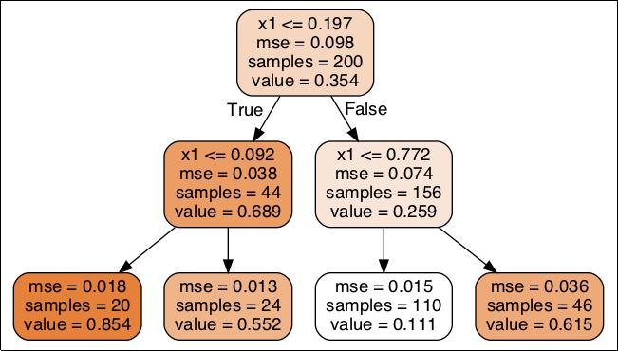

*Figure 6-4. A Decision Tree for regression*

This tree looks very similar to the classification tree you built earlier. The main differ‐ ence is that instead of predicting a class in each node, it predicts a value. For example, suppose you want to make a prediction for a new instance with *x*1 = 0.6. You traverse the tree starting at the root, and you eventually reach the leaf node that predicts value=0.1106. This prediction is simply the average target value of the 110 training instances associated to this leaf node. This prediction results in a Mean Squared Error (MSE) equal to 0.0151 over these 110 instances.

This model’s predictions are represented on the left of Figure 6-5. If you set max_depth=3, you get the predictions represented on the right. Notice how the pre‐ dicted value for each region is always the average target value of the instances in that region. The algorithm splits each region in a way that makes most training instances as close as possible to that predicted value.



**186** **|** **Chapter 6: Decision Trees**

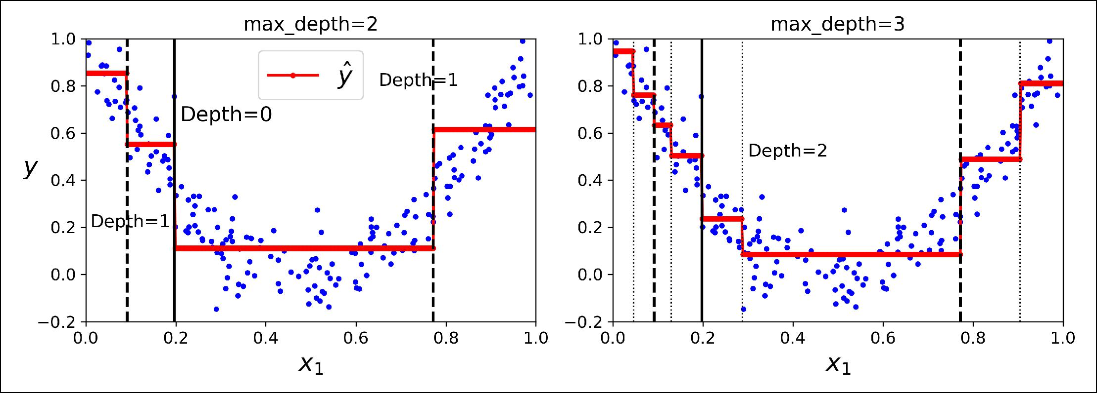

*Figure 6-5. Predictions of two Decision Tree regression models*

The CART algorithm works mostly the same way as earlier, except that instead of try‐ ing to split the training set in a way that minimizes impurity, it now tries to split the training set in a way that minimizes the MSE. Equation 6-4 shows the cost function that the algorithm tries to minimize.

*Equation 6-4. CART cost function for regression*

|  |  |  |  |  |  |  |
| --- | --- | --- | --- | --- | --- | --- |
| *J k*, *tk* = | *m*left | MSEleft + | *m*right | MSEright | where |  |
| *m* | *m* |  |



|  |  |  |  |  |  |
| --- | --- | --- | --- | --- | --- |
| MSEnode = | | ∑ | | *y*node− *y i* 2 |  |
|  | *i* ∈node | | |  |  |
| *y*node = | 1 |  | ∑ | *y i* |  |
|  |  |  |
|  | *m*node *i* ∈ node | | | |  |



Just like for classification tasks, Decision Trees are prone to overfitting when dealing with regression tasks. Without any regularization (i.e., using the default hyperpara‐ meters), you get the predictions on the left of Figure 6-6. It is obviously overfitting the training set very badly. Just setting min_samples_leaf=10 results in a much more reasonable model, represented on the right of Figure 6-6.

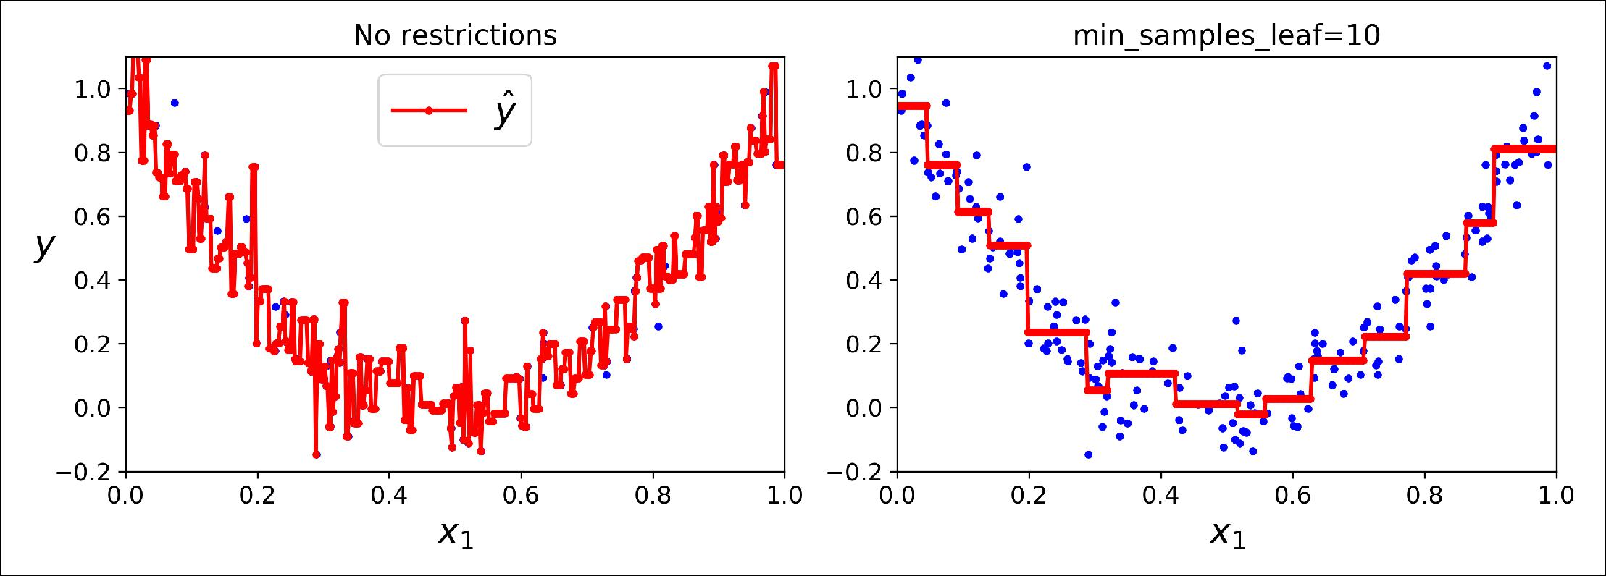

*Figure 6-6. Regularizing a Decision Tree regressor*



**Regression** **|** **187**

**Instability**

Hopefully by now you are convinced that Decision Trees have a lot going for them: they are simple to understand and interpret, easy to use, versatile, and powerful. However they do have a few limitations. First, as you may have noticed, Decision Trees love orthogonal decision boundaries (all splits are perpendicular to an axis), which makes them sensitive to training set rotation. For example, Figure 6-7 shows a simple linearly separable dataset: on the left, a Decision Tree can split it easily, while on the right, after the dataset is rotated by 45°, the decision boundary looks unneces‐ sarily convoluted. Although both Decision Trees fit the training set perfectly, it is very likely that the model on the right will not generalize well. One way to limit this prob‐ lem is to use PCA (see Chapter 8), which often results in a better orientation of the training data.

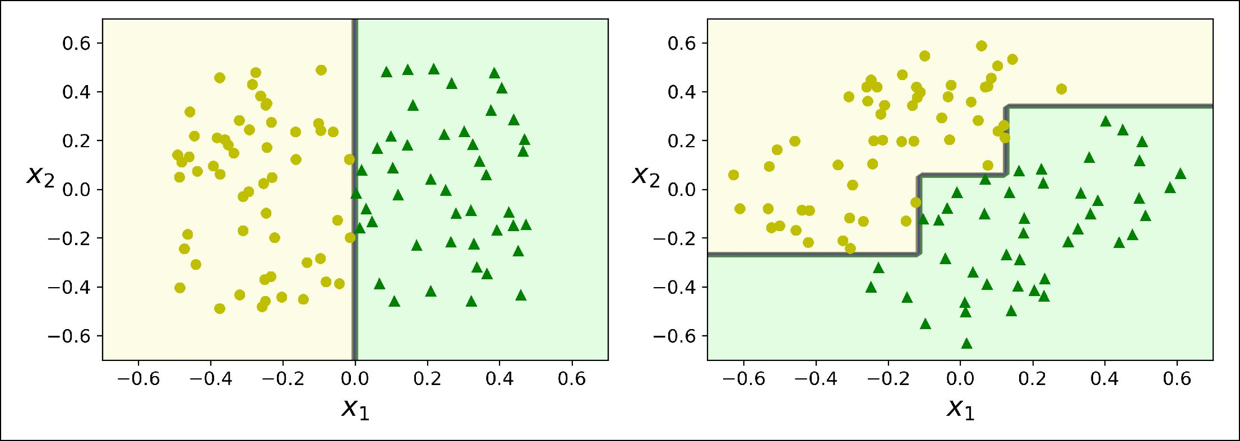

*Figure 6-7. Sensitivity to training set rotation*

More generally, the main issue with Decision Trees is that they are very sensitive to small variations in the training data. For example, if you just remove the widest Iris-Versicolor from the iris training set (the one with petals 4.8 cm long and 1.8 cm wide) and train a new Decision Tree, you may get the model represented in Figure 6-8. As you can see, it looks very different from the previous Decision Tree (Figure 6-2). Actually, since the training algorithm used by Scikit-Learn is stochastic6 you may get very different models even on the same training data (unless you set the random_state hyperparameter).



6 It randomly selects the set of features to evaluate at each node.



**188** **|** **Chapter 6: Decision Trees**

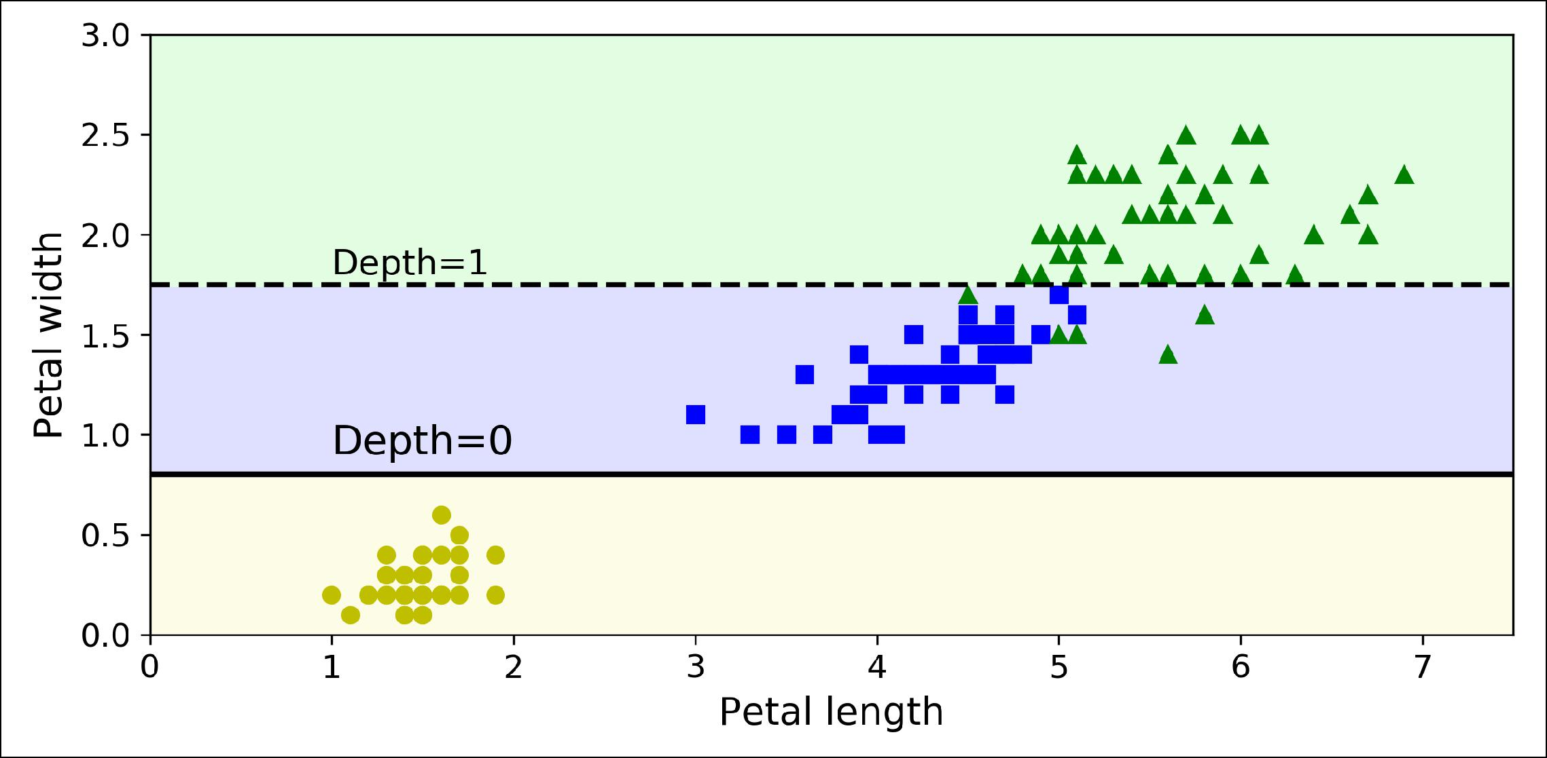

*Figure 6-8. Sensitivity to training set details*

Random Forests can limit this instability by averaging predictions over many trees, as we will see in the next chapter.

**Exercises**

1. What is the approximate depth of a Decision Tree trained (without restrictions) on a training set with 1 million instances?
2. Is a node’s Gini impurity generally lower or greater than its parent’s? Is it *gener‐* *ally* lower/greater, or *always* lower/greater?
3. If a Decision Tree is overfitting the training set, is it a good idea to try decreasing max_depth?
4. If a Decision Tree is underfitting the training set, is it a good idea to try scaling the input features?
5. If it takes one hour to train a Decision Tree on a training set containing 1 million instances, roughly how much time will it take to train another Decision Tree on a training set containing 10 million instances?
6. If your training set contains 100,000 instances, will setting presort=True speed up training?
7. Train and fine-tune a Decision Tree for the moons dataset.
   1. Generate a moons dataset using make_moons(n_samples=10000, noise=0.4).
   2. Split it into a training set and a test set using train_test_split().



**Exercises** **|** **189**

* 1. Use grid search with cross-validation (with the help of the GridSearchCV class) to find good hyperparameter values for a DecisionTreeClassifier. Hint: try various values for max_leaf_nodes.
  2. Train it on the full training set using these hyperparameters, and measure your model’s performance on the test set. You should get roughly 85% to 87% accuracy.

1. Grow a forest.
   1. Continuing the previous exercise, generate 1,000 subsets of the training set, each containing 100 instances selected randomly. Hint: you can use Scikit-Learn’s ShuffleSplit class for this.
   2. Train one Decision Tree on each subset, using the best hyperparameter values found above. Evaluate these 1,000 Decision Trees on the test set. Since they were trained on smaller sets, these Decision Trees will likely perform worse than the first Decision Tree, achieving only about 80% accuracy.
   3. Now comes the magic. For each test set instance, generate the predictions of the 1,000 Decision Trees, and keep only the most frequent prediction (you can use SciPy’s mode() function for this). This gives you *majority-vote predictions* over the test set.
   4. Evaluate these predictions on the test set: you should obtain a slightly higher accuracy than your first model (about 0.5 to 1.5% higher). Congratulations, you have trained a Random Forest classifier!

Solutions to these exercises are available in ???.



**190** **|** **Chapter 6: Decision Trees**